Homework Assignment 07

Name: Asrar Syed
Due by: April 15, 2026
Course Section: CSC 4330-002

- In the text:

- How many lines contain the literal string Harry ?

1084 lines

- How many instances of the literal string Harry are there?

1326 lines

Note: that the count for (a) should be less than (or equal to) the count for (b)—this is one way to check for correctness. TLDR…

If a line is: Harry met Harry.
- Counts it as 1 line
- Counts 2 instances.

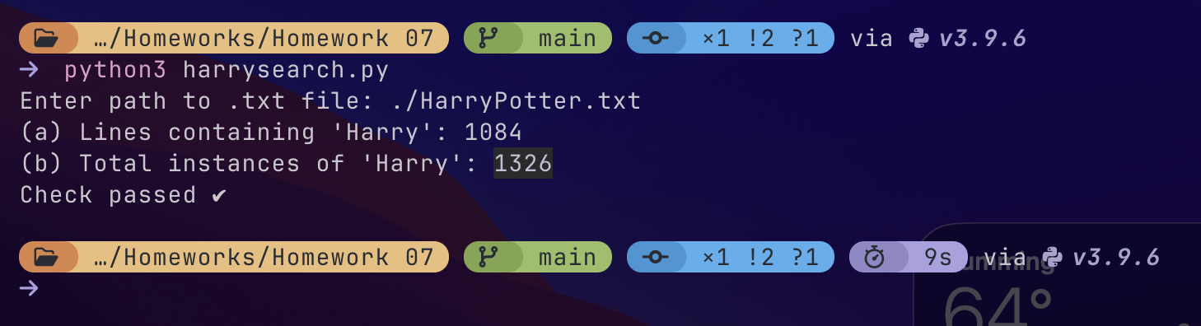

- In the text, how many times does the word “had” appear? Unlike the first exercise, which was
asking for instances of the literal string Harry, in this exercise, the goal is to find instances of the
word “had”, even if it begins a sentence or quote (e.g., strings Had and "Had), is at the end of a
sentence or clause (e.g., strings had. and had,), etc. Moreover, strings such as hadn’t, shade or
shadows do not count as instances of the word “had”.

See the following examples of tricky sentences which appear in the text, and the number of times
the word “had” appears in each such sentence:

- Had that been what the thieves were looking for? (1 time)
- And so he had. (1 time)
- Hedwig hadn’t brought Harry anything so far. (0 times)
- Then a small voice came out of the shadows. (0 times)
- Mrs. Dursley had had a nice, normal day. (2 times)

Note: that you may do this in several steps if you wish, e.g., perform a regex whose result can go
to some intermediate file, and then perform another regex on this intermediate file, etc.

702 times

Via doing:
# Step 1: remove punctuation (keep letters + spaces)
cleaned_line = re.sub(r"[^A-Za-z\s]", " ", line)

# Step 2: find whole word "had" (case-insensitive)
matches = re.findall(r"\bhad\b", cleaned_line, flags=re.IGNORECASE)

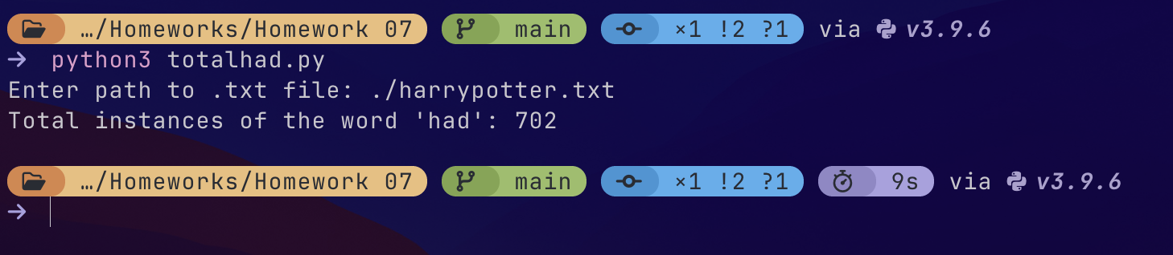

- Remember the regular language of exercise 2. of Homework 6—the language with an odd number of a’s? Now we want to generalize it to larger alphabets. In the text, how many words have an odd number of A’s/a’s? Here, word is defined as a contiguous set of printing characters including apostrophes ’ and hyphens -, where contiguity is broken by any whitespace character including space, tab, etc.

Note: watch out for contractions such as can’t or shouldn’ta (Hagrid has somewhat of a thick accent) as well as compound words such as last-minute or best-played. There is even an instance of what’s-her-name, which has both ’ and - (but would be a word with an even number of A’s/a’s according to the definition above).

Also: note, again, that you may do this in several steps if you wish, using any programming language and its features (not just regexes), e.g., Python’s split() function to split the text into some intermediate file, perform a regex on this file to produce a second intermediate file, etc. See the working examples in the slides “regexes-in-practice.pdf” for some inspiration.

24612 words with a odd number of A's/a's

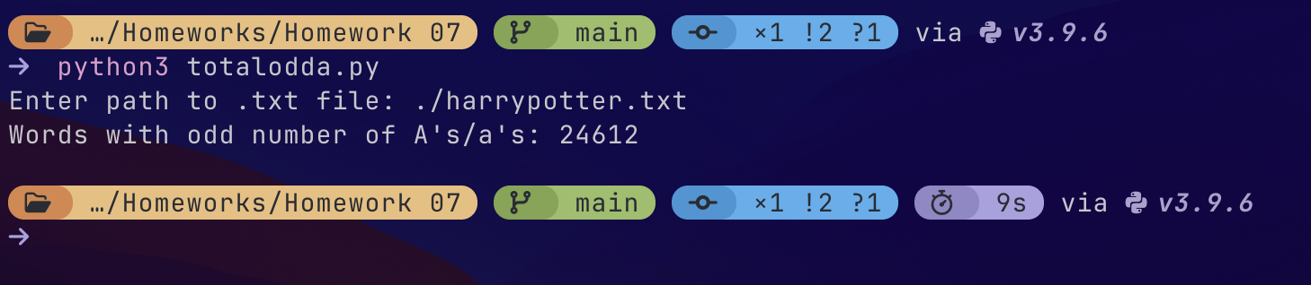

- Remember the regular languages of exercises 1. and 2. of Homework 6? Show that both of these languages are context-free languages by giving a corresponding context-free grammar for each. That is, show that:

- The language composed of all strings over the alphabet {a, b} of the form: zero or more a’s followed by zero or more b’s, i.e., {ε, a, b, aa, ab, abb, aaa, aab, abb, bbb, . . . }, where ε is the empty string, is context-free.

Language: a*b*

All strings with:
zero or more a’s, followed by
zero or more b’s

S AB
A aA | ε
B bB | ε

This works because:
A generates any number of a’s
B generates any number of b’s
S AB enforces all a’s come before b’s

- The language composed of all strings over the alphabet {a, b} that contain an odd number of a’s, is context-free.

total count of a’s = odd
b’s can appear anywhere

S bS | aT
T bT | aS | ε

S = state where we’ve seen an even number of a’s so far
T = state where we’ve seen an odd number of a’s

Transitions:
reading a flips between S T
reading b stays in same state
we accept from T (odd number of a’s), so T ε

Note that stating just the production rules is sufficient to describe the context-free grammar.

- Consider the language composed of all strings over the alphabet {a, b} that contain twice as many b’s as a’s, i.e., {ε, abb, bab, bba, aabbbb, ababbb, abbabb, abbbab, . . . } (note that the empty string ε is there for completeness, i.e., twice as many as zero is zero). Show that this language is context-free by giving a corresponding context-free grammar.

CFG that generates all strings over {a, b} where: #b = 2 * #a

Grammer should:
Add 1 a + 2 b’s together
Allow them to be arranged flexibly
Allow concatenation of valid strings

S ε
S aSbSbS
S bSaSbS
S bSbSaS

